
Fluid Flow Simulation Project Report
(###) ###-####

SOLIDWORKS Flow Simulation

Project Report

April 23, 2025

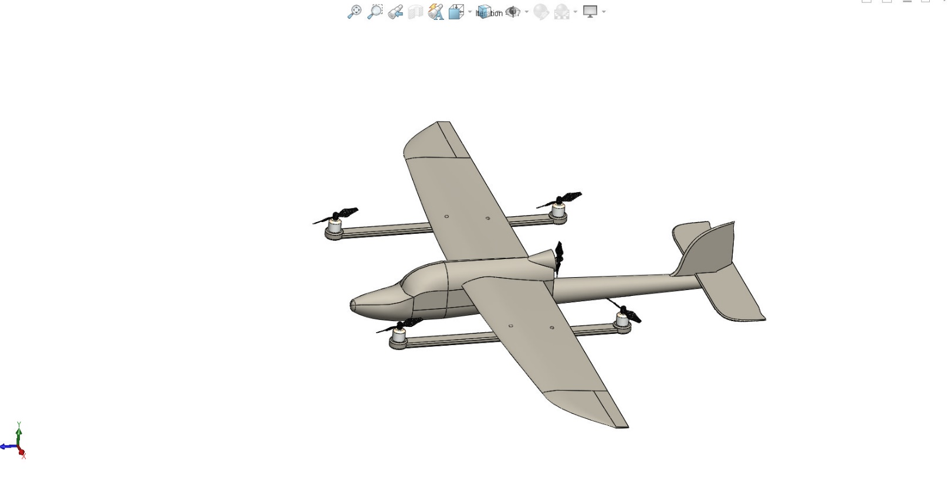

ANALYSED BY: AISHWARYA V SHAJU

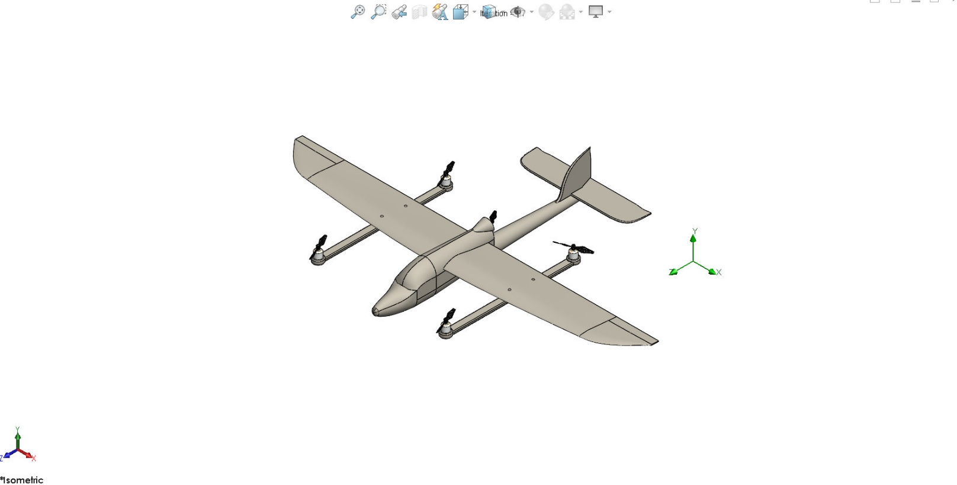

Table of Contents

1 General Information 1
1.1 Analysis Environment 1
1.2 Model Information 1
1.3 Project Comments: 1
1.4 Size of Computational Domain 1
1.5 Simulation Parameters 1
1.5.1 Mesh Settings 1
1.5.2 Material Settings 2
1.5.3 Initial Conditions 2
1.5.4 Boundary Conditions 2
1.5.5 Volumetric Heat Sources 2
1.5.6 Engineering Goals 2
1.6 Analysis Time 2
2 Results 2
2.1 Analysis Goals 2
2.2 Global Min-Max-Table 2
2.3 Results 2
2.4 Conclusion 2
3 Appendix 2
3.1 Material Data 2

General Information

Objective of the simulation: The objective of this simulation is to perform Computational Fluid Dynamics (CFD) analysis on the on a Hybrid VTOL Drone using SolidWorks Flow Simulation to study its aerodynamic performance. The analysis aims to evaluate key parameters such as pressure distribution, airflow patterns, velocity profiles, and drag forces acting on the drone during flight. This will help in understanding the aerodynamic efficiency of the design and identifying potential areas for performance optimization or design improvement.

Analysis Environment
Software Product: Flow Simulation 2023 SP0.0. Build: 5726
CPU Type: 12th Gen Intel(R) Core(TM) i7-12650H
CPU Speed: 2300 MHz
RAM: 16015 MB / 2947 MB
Operating System: Windows 11 (or higher) (Version 10.0.22631)

Model Information
Model Name: Skysurfer fixed wing VTOL UAV analysis.SLDASM
Project Name: aerodynamics analysis vtol

Project Comments:
Unit System: SI (m-kg-s)
Analysis Type: External (exclude internal spaces)

Size of Computational Domain

Size
X min | -0.817 m
X max | 1.874 m
Y min | 0.354 m
Y max | 1.768 m
Z min | -0.076 m
Z max | 2.488 m
X size | 2.692 m
Y size | 1.415 m
Z size | 2.565 m

Simulation Parameters

Mesh Settings

Basic Mesh

Basic Mesh Dimensions
Number of cells in X | 60
Number of cells in Y | 32
Number of cells in Z | 58

Analysis Mesh
Total Cell count: 113809
Fluid Cells: 113809
Solid Cells: 1571
Partial Cells: 1830
Trimmed Cells: 0

Additional Physical Calculation Options
Heat Transfer Analysis: Fluid Flow: OnConduction: Off
Flow Type: Laminar and turbulent
Time-Dependent Analysis: Off
Gravity: On
Radiation:
Humidity: Off
Default Wall Roughness: 0 micrometer

Material Settings

Material Settings
Fluids
Air

Initial Conditions

Ambient Conditions
Thermodynamic parameters | Static Pressure: 101325.00 Pa  Temperature: 20.05 °C
Velocity parameters | Velocity vector  Velocity in X direction: 0 m/s  Velocity in Y direction: 0 m/s  Velocity in Z direction: -120.000 m/s
Turbulence parameters | Turbulence intensity and length  Intensity: 0.10 %  Length: 0.002 m

Engineering Goals

Analysis Time
Calculation Time: 106 s
Number of Iterations: 97
Warnings:

Results

Analysis Goals

Goals
Name | Unit | Value | Progress | Criteria | Delta | Use in convergence

Global Min-Max-Table

Min/Max Table
Name | Minimum | Maximum
Density (Fluid) [kg/m^3] | 1.11 | 1.43
Pressure [Pa] | 94974.82 | 121286.19
Temperature [°C] | 17.04 | 27.18
Temperature (Fluid) [°C] | 17.04 | 27.18
Velocity [m/s] | 0 | 145.560
Velocity (X) [m/s] | -71.078 | 68.782
Velocity (Y) [m/s] | -37.518 | 46.189
Velocity (Z) [m/s] | -145.460 | 3.240
Mach Number [ ] | 0 | 0.43
Velocity RRF [m/s] | 0 | 145.560
Velocity RRF (X) [m/s] | -71.078 | 68.782
Velocity RRF (Y) [m/s] | -37.518 | 46.189
Velocity RRF (Z) [m/s] | -145.460 | 3.240
Vorticity [1/s] | 0.01 | 2891.58
Relative Pressure [Pa] | -6350.18 | 19961.19
Shear Stress [Pa] | 0 | 98.45
Bottleneck Number [ ] | 5.3757303e-14 | 1.0000000
Heat Transfer Coefficient [W/m^2/K] | 0 | 0
ShortCut Number [ ] | 8.3007010e-14 | 1.0000000
Surface Heat Flux [W/m^2] | 0 | 0
Surface Heat Flux (Convective) [W/m^2] | 0 | 0
Total Enthalpy Flux [W/m^2] | -4.434e+07 | 4.408e+07
Acoustic Power [W/m^3] | 0 | 0.006
Acoustic Power Level [dB] | 0 | 97.81

Results

CUT PLOT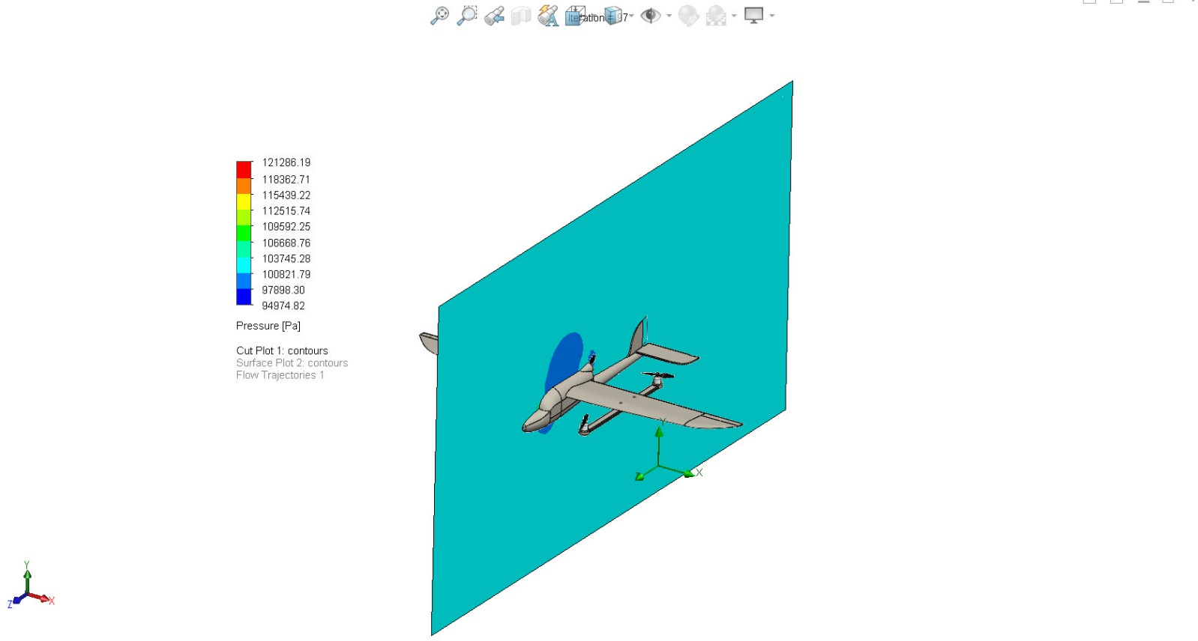

SURFACE PLOT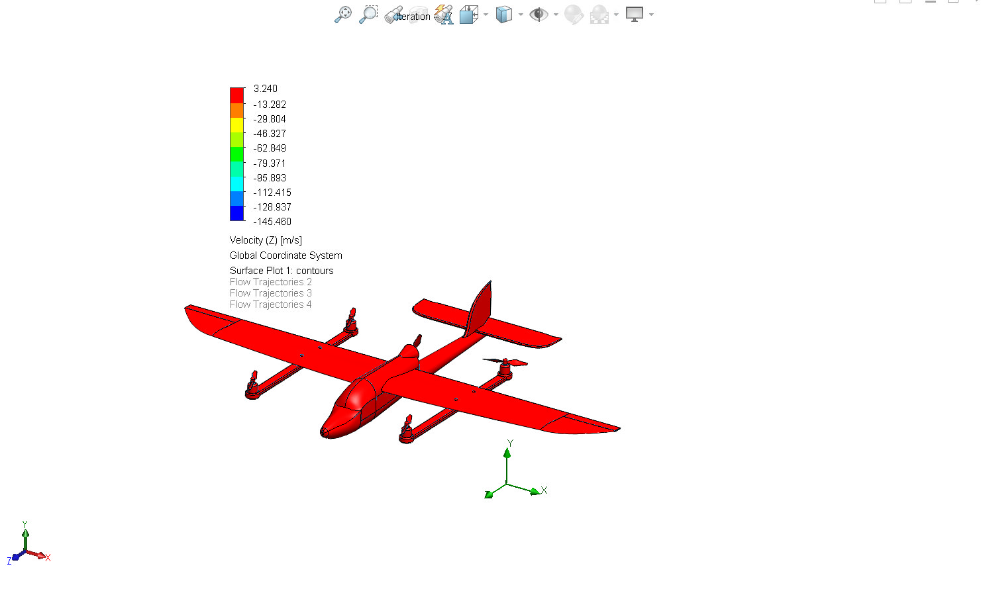
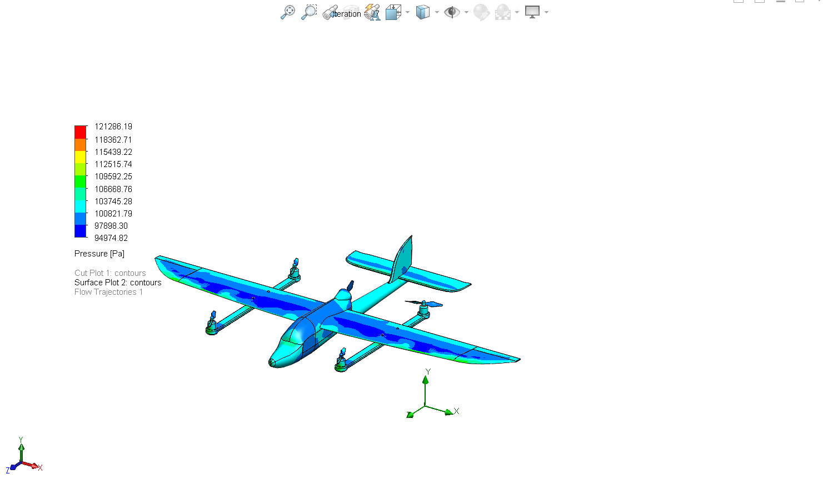

FLOW TRAJECTORIES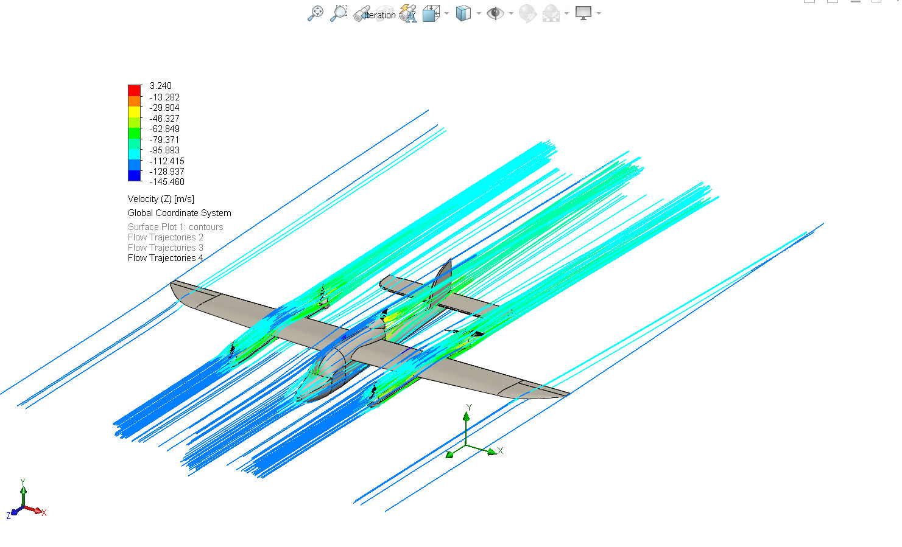

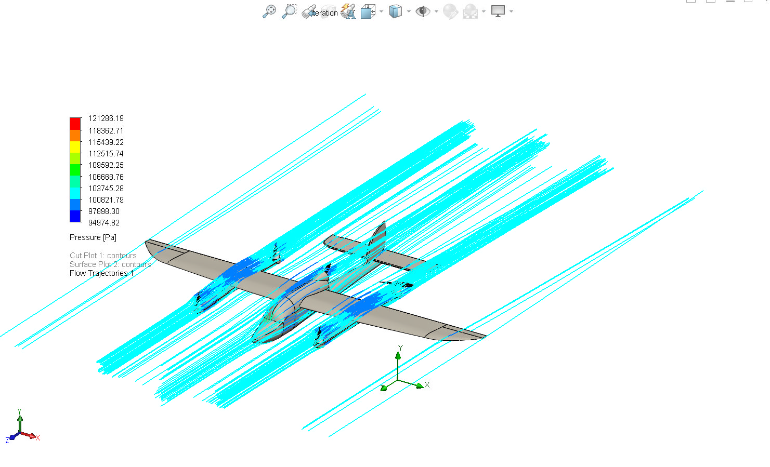

Conclusion

The CFD simulation conducted on the Hybrid VTOL drone successfully provided insights into its aerodynamic performance under defined flight conditions. The analysis revealed the airflow behavior around the fuselage and wings, highlighted regions of high and low pressure, and quantified drag forces acting on the drone.
From the results, it can be inferred that the aerodynamic design of the drone is optimized for steady flight with minimal turbulence and controlled pressure distribution. However, certain areas—such as wing-fuselage junctions or tail surfaces—may benefit from further refinement to reduce drag or improve lift-to-drag ratio.
Overall, this simulation demonstrates the importance of CFD analysis in validating and optimizing UAV designs for enhanced performance, stability, and efficiency during flight

Appendix

Material Data

Engineering Database
Gases
Air
Path: Gases Pre-Defined
Specific heat ratio (Cp/Cv): 1.399
Molecular mass: 0.0290 kg/mol
Dynamic viscosity

Specific heat (Cp)

Thermal conductivity

